Auckland Live Cabaret Season 2021 programme brochure

The Civic
Auckland Live’s shining jewel The Civic beckons you in for a winter festival feast of cabaret.

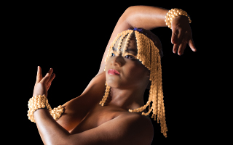

Contents
Auckland Live Cabaret Season 2021 programme brochure 1
Listings 4
Saturday 19 June 4
Tuesday 22 June 4
Wednesday 23 June 4
Thursday 24 June 4
Friday 25 June 5
Saturday 26 June 5
Sunday 27 June 6
Thursday 1 July 6
Friday 2 July 7
Saturday 3 July 7
Sunday 4 July 8
Tim Minchin 9
Tuawahine: Directed by Ria Hall 10
Edith Piaf à L'Olympia à Paris 11
A Vintage Cabaret Cinema 12
Fever: The Return of the Ula 13
Rock Follies Forever 14
Thoroughly Modern Māui 15
The Most Naked 16
Let It Beatles 17
Both Sides Now 18
Hardcase Hori Housie 19
Finn Andrews and NZTrio 20
Les Femmes 21
The Glitter Garden 22
Naked Girls Reading 23
Sad Songs 24
The Secret Piano Bar 25
High Tea on The Mezz 26
Soul Lounge 27
Ladies Who Brunch 28
Jackie Goes Prima Diva 29
A Fine Romance: The Magic of Fred Astaire 30

Listings

Saturday 19 June
Tim Minchin | 8 pm
$79.90 - $230*
Mainstage, The Civic

Tuesday 22 June
A Vintage Cabaret Cinema: Cabaret
6 pm | $15 – $18*
Mainstage, The Civic

Wednesday 23 June
A Vintage Cabaret Cinema: Funny Girl
3 pm | $15 – $18*
Mainstage, The Civic

Rock Follies Forever
6.30 pm | $55 – $65*
Wintergarden, The Civic

Fever: The Return of the Ula
8.30 pm | $45 – $55*
Wintergarden, The Civic

Thursday 24 June
A Vintage Cabaret Cinema: Dreamgirls
3 pm | $15 – $18*
Mainstage, The Civic

Rock Follies Forever
7 pm | $55 – $65*
Wintergarden, The Civic

Naked Girls Reading
7 pm | $25 – $29
Theatre Bar, The Civic

The Most Naked
9 pm | $39 – $45*
Wintergarden, The Civic

Friday 25 June
A Vintage Cabaret Cinema: All That Jazz
2 pm | $15 – $18*
Mainstage, The Civic

The Glitter Garden
6.30 pm | $21 – $28*
Herald Theatre, Aotea Centre

Thoroughly Modern Māui
6.30 pm | $45 – $55*
Wintergarden, The Civic

Rock Follies Forever
8.30 pm | $55 – $65*
Wintergarden, The Civic

Sad Songs
10 pm | Free
Theatre Bar, The Civic

Fever: The Return of the Ula
10.30 pm | $45 – $55*
Wintergarden, The Civic

A Vintage Cabaret Cinema:
The Rocky Horror Picture Show
Midnight | $15 – $18*
Mainstage, The Civic

Saturday 26 June
The Glitter Garden
10 am and 1 pm | $21 – $28*
Herald Theatre, Aotea Centre

High Tea on the Mezz: Ladies who Brunch
11.30 am | $80 – $89*
Mezzanine, The Civic

A Vintage Cabaret Cinema: Cabaret
2 pm | $15 – $18*
Mainstage, The Civic

High Tea on the Mezz: A Fine Romance
2.30 pm | $80 – $89*
Mezzanine, The Civic

Let it Beatles
5 pm | $39 – $45*
Wintergarden, The Civic

Hardcase Hori Housie
7 pm | $39 – $45*
Wintergarden, The Civic

The Most Naked
9 pm | $39 – $45*
Wintergarden, The Civic

Fever: The Return of the Ula
10.30 pm | $45 – $55*
Wintergarden, The Civic

The Rocky Horror Picture Show
Midnight | $15 – $18*
Mainstage, The Civic

Sunday 27 June
The Glitter Garden
10 am and 1 pm | $21- $28*
Herald Theatre, Aotea Centre

High Tea on the Mezz: A Fine Romance
11.30 am | $80 – $89*
Mezzanine, The Civic

High Tea on the Mezz: Soul Lounge
2.30 pm | $80 – $89
Mezzanine, The Civic

Both Sides Now
6 pm | $55 – $65*
Wintergarden, The Civic

A Vintage Cabaret Cinema: Funny Girl
8 pm | $15 – $18*
Mainstage, The Civic

Thursday 1 July
Naked Girls Reading
7 pm | $25 – $29
Theatre Bar, The Civic

The Most Naked
7 pm | $39 – $45*
Wintergarden, The Civic

Throughly Modern Māui
9 pm | $45 – $55*
Wintergarden, The Civic

Friday 2 July
Naked Girls Reading
6 pm | $25 – $29*
Theatre Bar, The Civic

Fever: The Return of the Ula
6.30 pm | $45 – $55*
Wintergarden, The Civic

Tuawahine
8 pm | $49 – $119*
Mainstage, The Civic

Saturday 3 July
High Tea on the Mezz: Soul Lounge
11:30 am and 2:30 pm | $80 – $89*
Mezzanine, The Civic

Hardcase Hori Housie
4 pm | $39 – $45*
Wintergarden, The Civic

Let it Beatles
6 pm | $39 – $45* Wintergarden, The Civic

Edith Piaf à L’Olympia à Paris
7 pm | $79 – $125*
Mainstage, The Civic

Finn Andrews and NZTrio
9.30 pm | $55 – $65*
Wintergarden, The Civic

Sad Songs
10.30 pm | Free
Theatre Bar, The Civic

Les Femmes
11 pm | $45 – $55*
Wintergarden, The Civic

Sunday 4 July
High Tea on the Mezz: Jackie Goes Prima Diva
11.30 am and 2.30 pm | $80 – $89*
Mezzanine, The Civic

Both Sides Now
4 pm | $55 – $65*
Wintergarden, The Civic

Finn Andrews and NZTrio
7 pm | $55 – $65*
Wintergarden, The Civic

For Accessibility information and to book visit www.aucklandlive.co.nz

All remaining links in this document are to the booking page on Ticketmaster

By special arrangement for Auckland Live Cabaret Season

Tim Minchin
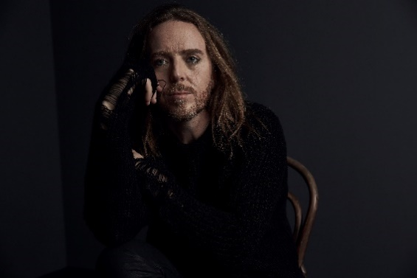
Internationally renowned, award-winning musician, comedian, actor, writer and composer, Tim Minchin will return to New Zealand for the encore of ‘Back’ this June.
After sold-out shows across NZ in 2019, ‘Back’ returns with a set list of material from all corners of Minchin’s eclectic – and often iconoclastic – repertoire.
Minchin has been celebrated globally for writing the music and lyrics for ‘Matilda The Musical’, which has gone on to become one of the most acclaimed musicals of the last 20 years, winning a record seven Olivier Awards and five Tony Awards.

When: Saturday 19 June, 8 pm
Where: Mainstage, The Civic
Duration: 120 minutes
Tickets: $79.90 - $230. Service fees apply.
Presented by Live Nation

Tuawahine: Directed by Ria Hall
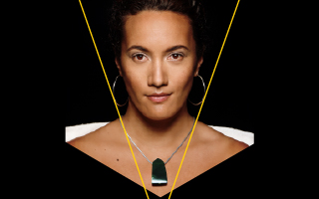
‘Tuawahine’ is a celebration of Matariki and the power of wāhine toa. With musical direction by Ria Hall, ‘Tuawahine’ is a live music experience featuring iconic and up-and-coming female artists from across the cultural spectrum including Anika Moa, Tami Neilson, Georgia Line, and Paige with more to be announced.
Presenting a spellbinding mix of reimagined classics, original songs, and waiata Māori with the backing of a stellar band, ‘Tuawahine’ is an unmissable event.

When: Friday 2 July, 8 pm
Where: Mainstage, The Civic
Duration: 120 minutes
Tickets: $49 - $119. Service fees apply.
Presented by Auckland Live with JANDA Productions.

Edith Piaf à L'Olympia à Paris
Performed by Yulia by special invitation
Be at The Civic for an electrifying performance by one of our most inspiring talents, accompanied by a 14-piece orchestra and band. Yulia reaches across the ages and channels the great chanteuse Edith Piaf, performing at the peak of her powers. Celebrating 60 years since Edith Piaf’s classic concert album, ‘Récital 1961’, Yulia will transport us to the place of Piaf’s most powerful performances - L'Olympia à Paris.

When: Saturday 3 July, 7 pm
Where: Mainstage, The Civic
Duration: 120 minutes
Tickets: $79 - $125. Service fees apply.
Presented by Auckland Live with Liberty Stage

A Vintage Cabaret Cinema
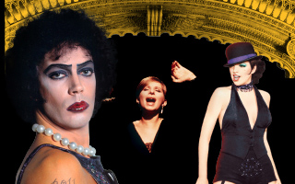
A Vintage Cabaret Cinema celebrates the nostalgia of Auckland’s beautiful ‘atmospheric’ theatre, screening classic cabaret and musical film titles including ‘Funny Girl’, ‘All That Jazz’, ‘Dream Girls’ and a special midnight screening of cult-classic ‘The Rocky Horror Picture Show’.
Sit beneath the starts and wander back in time with films that share a place in history and our hearts, and soak in the gilded splendour of this this sumptuous theatre.

When: 22 – 27 June
Where: Mainstage, The Civic
Tickets: $15 - $18. Service fees apply.
Presented by Auckland Live

Fever: The Return of the Ula
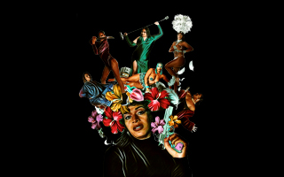
Category is: Fine-extravaganza-hold-onto-yourmanz-aaah! Purrr…
The savage stomps and luscious sways of Fine Fatale will delve into your deepest fantasies and wildest dreams to bring to life a ‘D for Divine’ cabaret.
Hosted by the soulful roars of the trilling trio The Taka Tu Wops, get ready for a night out that will tickle your fancies, pump up your heart rate, and send the city to Alert Level 10!

When: Wednesday 23 June, 8.30 pm; Friday 25 June,10.30 pm; Saturday 26 June, 10.30 pm; Friday 2 July, 6.30 pm.
Where: Wintergarden, The Civic
Duration: 60 minutes
Tickets: $45 - $55. Service fees apply.
Presented by Auckland Live and Fine Fatale

Rock Follies Forever
‘Rock Follies Forever’ is an ode to the fabulousness of the cult British TV series ‘Rock Follies’, a show chronicling the ups and downs of three fierce women climbing the ladder to success in the macho world of 1970’s rock.
Featuring original songs from the TV show (penned by Roxy Music’s Andy MacKay), alongside a glam selection of stonking mega-hits of the era, think Ziggy Stardust, Suzi Quatro and T. Rex.
Performed by three legends of New Zealand entertainment — Jackie Clarke, Laura Daniel and Jennifer Ward-Lealand — backed by a brilliant band led by keys maestro Grant Winterburn.
Fall in love with Rock Follies Forever — the 1970’s British girl-group that never was — until now.

When: Wednesday 23 June, 6.30 pm; Thursday 24 June, 7 pm; Friday 25 June, 8.30 pm
Where: Wintergarden, The Civic
Duration: 60 minutes
Tickets: $55 - $65. Service fees may apply.
Presented by Auckland Live and Granite Jack

Thoroughly Modern Māui
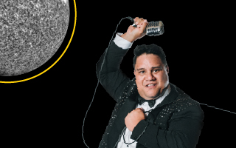
Many moons ago, a superhero of a different kind ruled this side of the Pacific. His name was Māui-Tikitiki-A-Taranga.
A warrior and demigod, his adventures are woven into the fabric of Pacific history. Here in Aotearoa, this ‘Māori Superman’ enjoyed the best of the natural and spiritual worlds. He was fast, fit, and funny. He was the total package.
Join Rutene Spooner on his quest to discover what it takes to become the modern day Māori hero. Who knows what might unravel in his path! Perhaps this ‘haka-boogie-hori’ will realise that in order to cast forward, he must pull from the past, back to the ancient ones.

When: Friday 25 June, 6.30 pm; Thursday 1 July, 9 pm
Where: Wintergarden, The Civic
Duration: 60 minutes
Tickets: $45 - $55. Service fees apply.
Presented by Auckland Live and Metro Māori Productions

The Most Naked
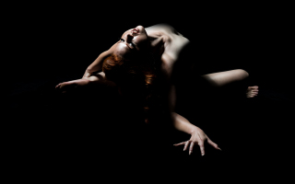
Fearlessly sinking its teeth into cultural mores around nudity, strip tease and the flashing of skin, The Most Naked is a live art experience that strips nakedness to the bone.
Compelling, absurd and unsettlingly sexy, this multi-disciplinary performance work-cum-cabaret will invigorate and interrogate as audiences take an explorative journey to the relationship with nudity.
Created and performed by force-of-nature movement alchemist, Hannah Tasker-Poland, with the wizardry of internationally renowned composer and musician Lucien Johnson.

When: Thursday 24 June, 9 pm; Saturday 26 June, 9 pm; Thursday 1 July, 7 pm
Where: Wintergarden, The Civic
Duration: 60 minutes
Tickets: $39 - $45. Service fees apply.
Presented by Auckland Live and Hannah Tasker-Poland|project MUSE

Let It Beatles
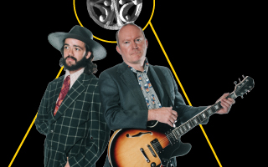
How did one unlikely group of four run-of-the-mill lads from Liverpool become the most influential band of the last 60 years?
Four local hard-working musos Paul McLaney (Gramsci, The Impending Adorations), Alex Freer (Tiny Ruins, Ladyhawke), Jonathan Burgess (Demons of Noon) and musical director Robin Kelly (Here Lies Love, Valerie) delve deep inside their own music journeys to answer this question and play their dream gig, recreating the music of The Beatles.
From the pop bangers that made the fans scream and shout — ‘Eight Days A Week’, ‘Day Tripper’, ‘I Saw Her Standing There’ — to tripping out on their psychedelic musings ‘Across the Universe’ and ‘I am the Walrus’.

When : Saturday 26 June, 5 pm ; Saturday 3 July, 6 pm
Where : Wintergarden, The Civic
Duration : 60 mins
Tickets : $39 - $45. Service fees apply.
Presented by Auckland Live and The Nowhere Men

Both Sides Now
With a voice known to span honey-sweet falsetto through to menacing growl, Julia Deans (Fur Patrol, The Adults), unleashes her formidable talents on Joni Mitchell’s iconic songbook in ‘Both Sides Now’ - in collaboration with director Shane Bosher.
For audiences this will be an emotional journey back to the heart of Joni Mitchell and her music ‘River’, ‘Blue’, ‘Big Yellow Taxi’, and ‘Woodstock’ that will be profound, personal and deeply intimate.

When : Sunday 27 June, 6 pm ; Sunday 4 July, 4 pm
Where : Wintergarden, The Civic
Duration : 90 minutes
Tickets : $55 - $65. Service fees apply.
Presented by: Auckland Live and Brilliant Adventures

Hardcase Hori Housie
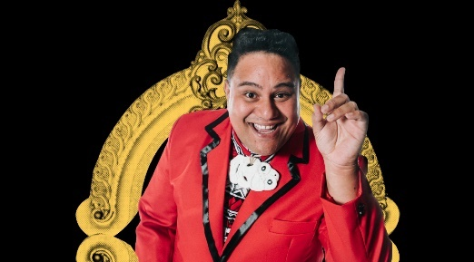
Ready? Eyes down! ‘Cos there’s a flash new game in town!
Join cheeky host and acclaimed entertainer Rutene Spooner, as he calls a night of hard-case Māori humour and classic Kiwi tunes while you spin, win, and grin through a game of Housie! Rutene’s got the warm honey tones, rib-cracking jokes and a kete packed full of prizes.
Grab yourself a dozen of your closest cuzzies, and pour yourself a sherry. It’s the Māori way to play a Hardcase Hori Housie — just like a game of bingo, only brown.

When: Saturday 26 June, 7 pm; Saturday 3 July, 4 pm
Where: Wintergarden, The Civic
Duration: 60 minutes
Tickets: $39 - $45. Service fees apply.
Presented by Auckland Live and Metro Māori Productions

Finn Andrews and NZTrio
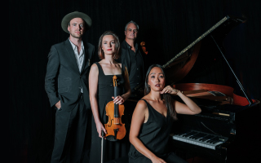
Finn Andrews, lead singer of The Veils, joins forces with Amalia Hall, Ashley Brown, and Somi Kim of NZTrio to perform songs from Finn’s first solo album ‘One Piece at a Time’.
Masterfully arranged by composer Victoria Kelly, these exquisitely touching works take on a new power using the combined musical impact of these talented musicians. Expect to be affected.

When: Saturday 3 July, 9.30 pm; Sunday 4 July, 7 pm
Where: Wintergarden, The Civic
Duration: 60 minutes
Tickets: $55 - $65. Service fees apply.
Presented by Auckland Live, NZTrio and Banished Music.

Les Femmes
Lighting up the late-night slot on the Wintergarden stage are glamazons Miss Manage, Miss Givings, and Miss Demeanor in their cabaret sensation ‘Les Femmes’.
This fabulous trio, along with their seven-piece band, will be sashay-ing their way through a greatest hits songbook of much-loved girl bands including Diana Ross and The Supremes, the Pussy Cat Dolls, the Spice Girls, and so many more.

Slam your body down and say yes to being there!

When: Saturday 3 July, 11 pm
Where: Wintergarden, The Civic
Duration: 90 minutes
Tickets: $45 - $55. Service fees apply.
Presented by Auckland Live and J R Entertainment

The Glitter Garden
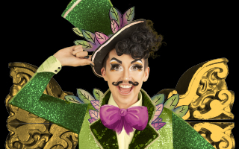
Discover the enchanting world of ‘The Glitter Garden’, where you will meet Hugo the Gardener, Skipper the snail, Honey the bee, and all their sparkling buddies.
Together they will take you and your whānau through a magical Pride parade of sensational costumes, song, dance and hilarity.
You’ll leave empowered by self care, and loving life and planter boxes.

When: Friday 25 June, 6.30 pm; Saturday 26 June, 10 am & 1 pm; Sunday 27 June, 10 am & 1 pm
Where: Herald Theatre, Aotea Centre
Duration: 60 minutes
Tickets: $21 - $28. Service fees apply.
Presented by Auckland Live and Hugo Grrrl | Created by Loro Leigh and George Fowler

Naked Girls Reading
A sexy book club, a sapphic slumber party, a sumptuous and scandalous cabaret show sure to arouse, educate, and entertain all at once.
With a brand-spanking new cast (don’t spank the cast), expect poetry, literature, non-fiction and, of course, the worst and most hilarious erotica the Internet can provide.
Experience the ancient and beautiful art of storytelling, in a beautiful, body-positive nakedness celebration.

When: Thursday 24 June, 7 pm; Thursday 1 July, 7 pm; Friday 2 July, 6 pm
Where: Theatre Bar, The Civic
Duration: 60 minutes
Tickets: $25 - $29. Service fees apply.
Presented by Auckland Live and Hugo Grrrl

Sad Songs
The Spooners, three devilishly handsome musical aficionados — Milan Borich, Jonathan Burgess and Abraham Kunin — will tear at your heartstrings with ‘Sad Songs’.
No strangers to crooning from the corners of darkened bars, these troubadours traverse the vast emotional plains of the greats including Tom Waits, Nick Cave, and Percy Sledge.
This deliciously despairing musical feast is a Cabaret Season treat, taking place inside the intimacy of The Civic’s Theatre Bar.

When: Friday 25 June, 10 pm; Saturday 3 July, 10.30 pm
Where: Theatre Bar, The Civic
Duration: 60 minutes
Tickets: Free
Presented by Auckland Live

The Secret Piano Bar
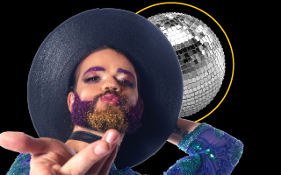
Discover the secret doorway to Auckland’s hidden bar packed with cabaret artists, musicians, cocktails, and late-night magic!
Storm the stage and belt a tune or sit and sip a martini in a darkened corner while absorbing the timeless underground carnival vibe of the Cabaret Season’s secret hideout.
Hosted by master pianist, Robin Kelly, and packed with a stellar line-up every night, The Secret Piano Bar’s an intimate space, and while entry is always desired - it's never guaranteed!

When: Every night
Where: 12 Wellesley Street West. Access patrons, please speak to staff in the Civic, who will guide you along the secret route to the secret bar.
Created by Auckland Live

High Tea on The Mezz
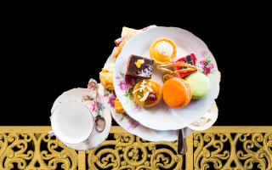
Savour and devour this utterly delectable Cabaret Season offering that will set your senses alight. Join us for an afternoon of high tea on the Mezzanine at The Civic, where a divine menu packed with sweet and savoury treats is perfectly paired with bubbles and an exquisite cabaret show. This rare, intimate, and sumptuous special event pays a nostalgic nod to times gone by as we invite you to indulge and enjoy with a bird’s eye view of The Civic foyer.
Be serenaded by ‘Soul Lounge’, ‘Ladies Who Brunch’, ‘Jackie Goes Prima Diva’, and ‘A Fine Romance’.
Duration of 90 minutes. Bookings are essential as seats are limited.

Soul Lounge
Experience powerhouse trio Paul Fagamalo, Brady Peeti and Kristin Paulse as these rising superstars take you on a journey from the pioneering divas and master of RnB of yesteryear to the soul masters of today.
The vocal stylings of these soul kweens and their POC band will be a raptuous celebration of the music that’s inspired them as artists, reinvigorating their favourite anthems for a new generation.

High Tea On The Mezz
When : Sun 27 Jun, 2.30 pm ; Sat 3 Jul, 11.30 am & 2.30 pm
Where : Mezzanine, The Civic
Duration : 90 minutes
Tickets : $80 - $89. Service fees apply.
Presented by Auckland Live, Paul Fagamalo, Brady Peeti and Kristin Paulse

Ladies Who Brunch
Join the glamazons of ‘Les Femmes’ – Miss Manage, Miss Givings, and Miss Demeanour – for a delicious, drag-filled 90 minutes of sensational tunes, slick harmonies, and sumptuous treats at the very first High Tea At The Mezz.
These queens will strut their stuff in stunning style, belting out the greatest hits of much-loved girl bands spanning The Supremes, the Pointer Sisters, the Spice Girls, and more.

High Tea On The Mezz
When : Saturday 26 July, 11.30 am
Where : Mezzanine, The Civic
Duration : 90 minutes
Tickets : $80 - $89. Service fees apply.
Presented by Auckland Live and J R Entertainment

Jackie Goes Prima Diva
Our very own Grey Lynn diva, Jackie Clarke pays tribute to her musical idols, from grande dames Judy Garland and Peggy Lee to Dolly Parton, Lady Gaga and more!
Accompanying Jackie on piano will be the mercurial Grant Winterburn, and together this dynamic duo will deliver a personal and celebratory show of iconic songs.
Don’t miss this intimate tribute from the loving larynx of a truly bright musical star.
High Tea On The Mezz
When: Sunday 4 July, 11.30 am & 2.30 pm
Where: Mezzanine, The Civic
Duration: 90 minutes
Tickets: $80 - $89. Service fees apply.
Presented by Auckland Live and Granite Jack

A Fine Romance: The Magic of Fred Astaire
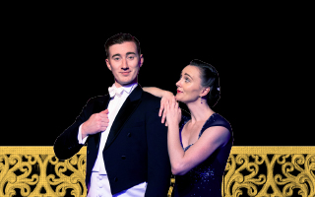
‘Can’t sing, can’t act, slightly balding, can dance a little’ – Fred Astaire. What a legend — no wonder he is still adored by millions of fans around the world today.

A Fine Romance re-creates the story of Fred Astaire, from his humble beginnings on Broadway to Hollywood stardom. Expect beautiful costumes, extraordinary dance moves and of course, timeless music with songs including ‘The Way You Look Tonight’, ‘Cheek to Cheek’, ‘Putting on the Ritz’, and so many more.
High Tea On The Mezz

When : Saturday 26 June, 2.30 pm ; Sunday 27 June, 11.30 am
Where : Mezzanine, The Civic
Duration : 90 minutes
Tickets : $80 - $89. Service fees apply.
Presented by Auckland Live and J R Entertainment

